Static Web Page : A page with no interaction

HTML : Hyper Text Markup Language

Which means it is made up of some tags

Structure of html page

<html>

<head>

What we write here is related to the page , not visible in the browser

</head>

<body>

Whatever we write here, will be visible on the browser

</body>

</html>

<> Contents </> Container Tag

<>Empty tag

<h1> </h1>

Tags : Container Tags, Empty Tags

Container Tags : which contains text in between them

<h1> Hello </h1>

<body> </body>

<p> </p>

Empty Tags : which are not required to be close

<br> Line Break

<hr>

<img>

Structure of html page

<html>

<head>

</head>

<body>

</body>

</html>

<!DOCTYPE html>

<html>

<head>

<meta charset="utf-8" />

<title></title>

</head>

<body>

<form>

Enter Name <input type="text" id="name" />

<br />

Enter Marks <input type="number" id="marks" min="0" max="100" />

<br />

Enter EMail <input type="email" id="email"/>

<br />

Date of Joing <input type="date" id="doj"/>

</form>

</body>

</html>

HTML : Hyper text markup Language

Features of HTML :

1. It is Markup language
2. It is case insensitive
3. It is made up of tags

Extenstion of Html page is .html / .htm

HTML is used for making static web pages



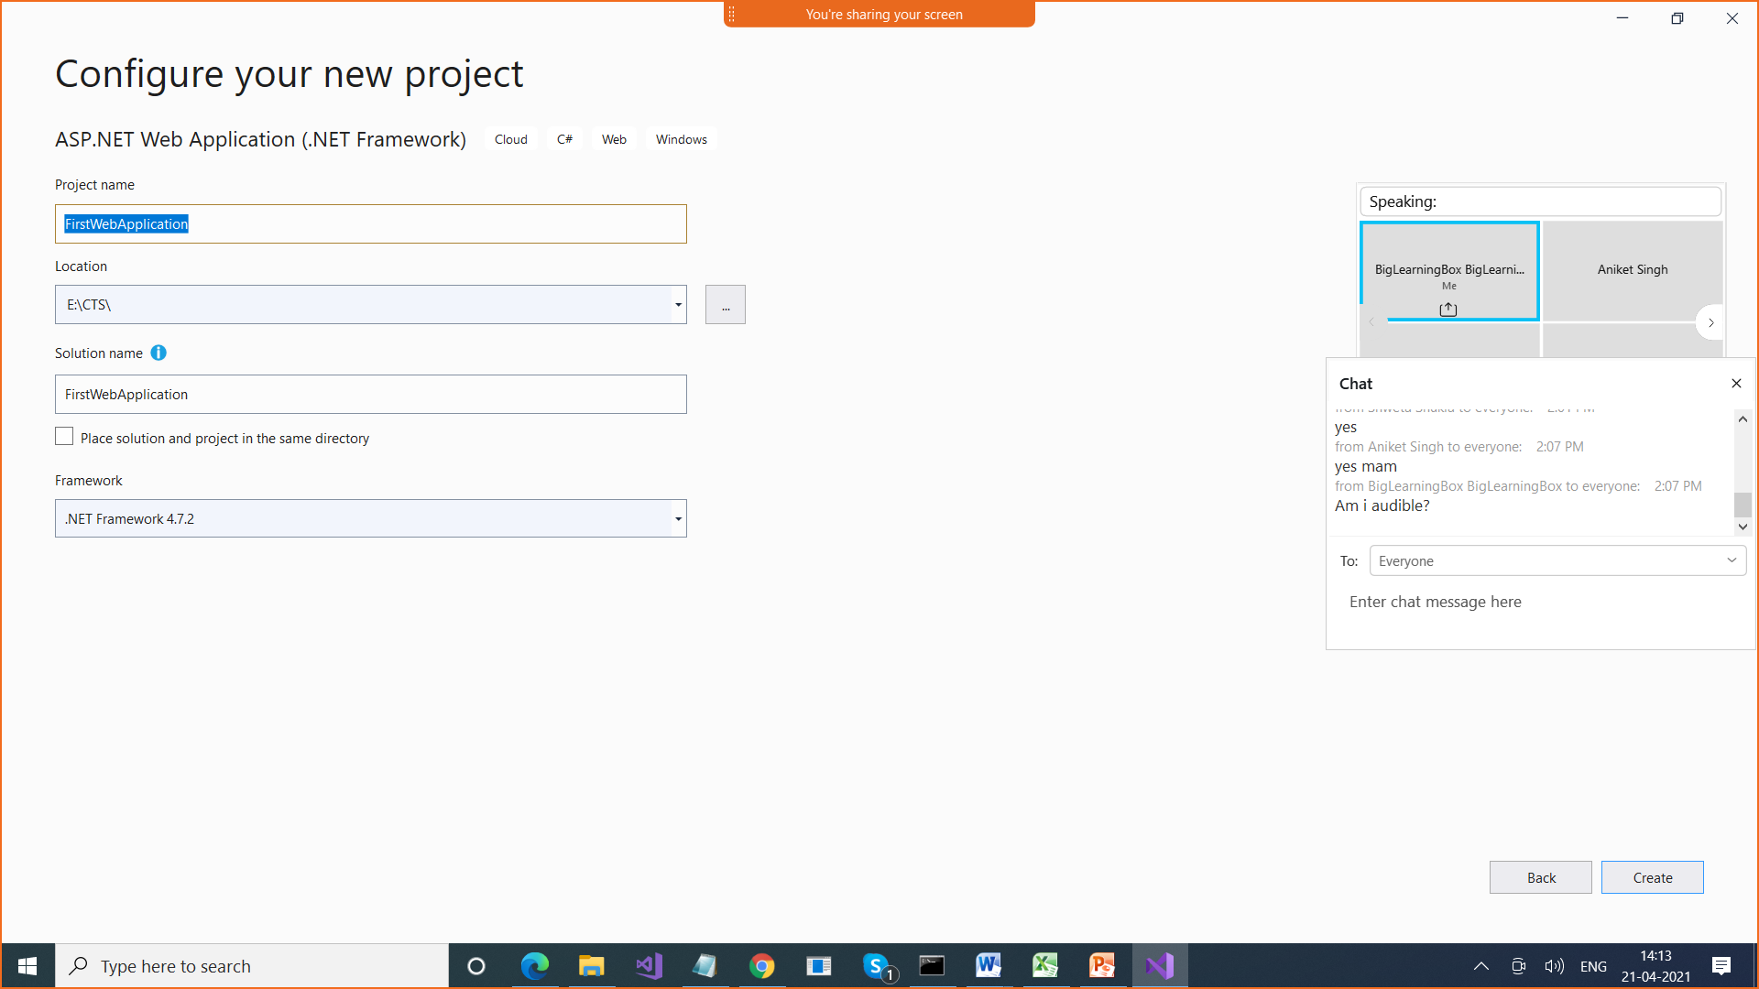

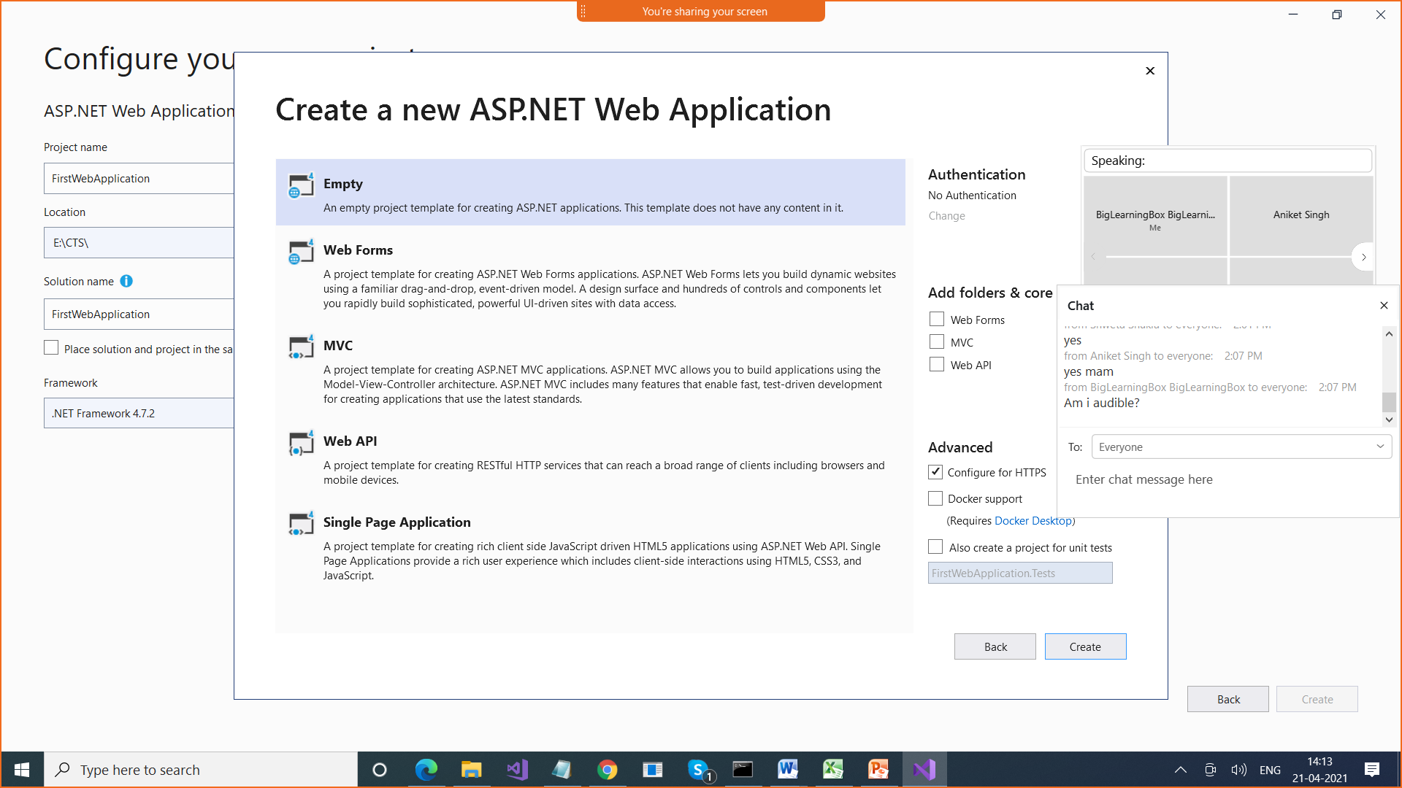

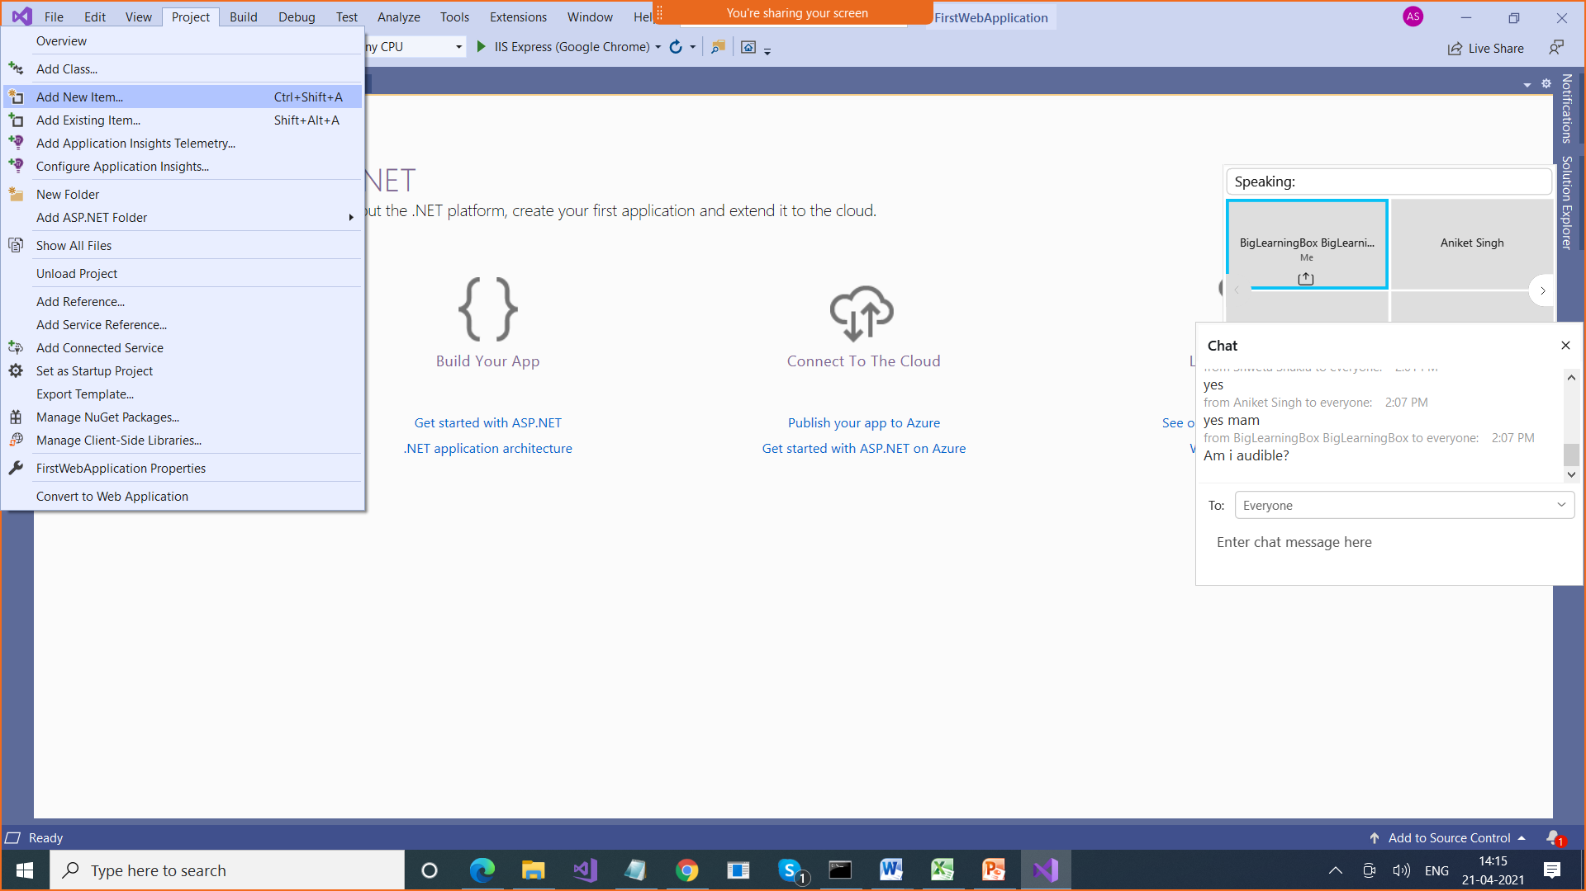

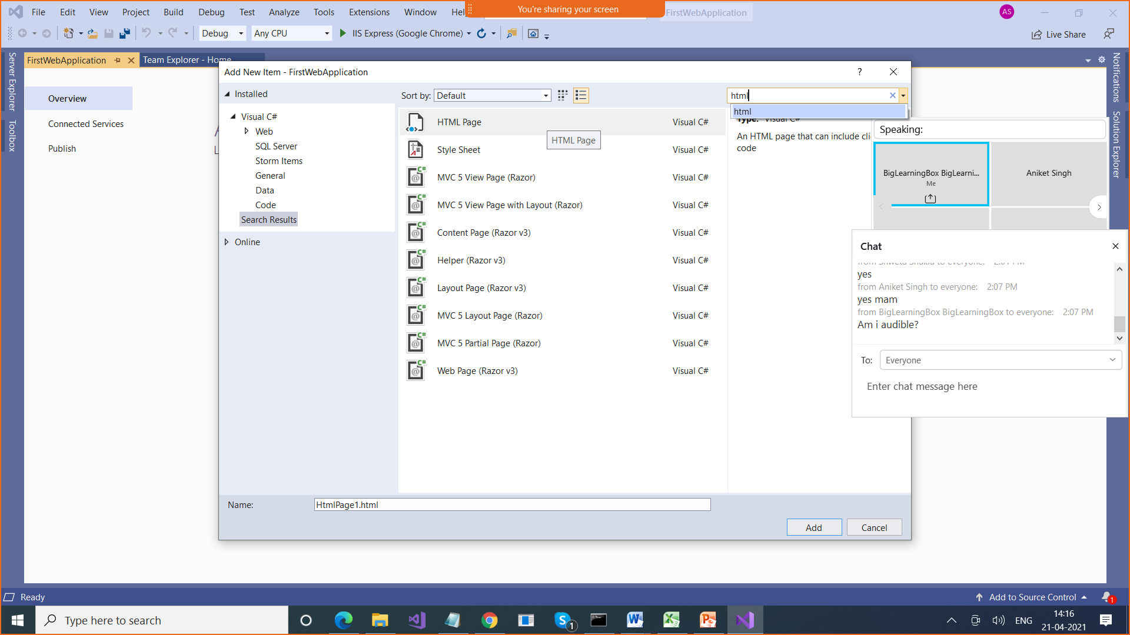

<!DOCTYPE html>

This statement tells you that we are using HTML 5 version

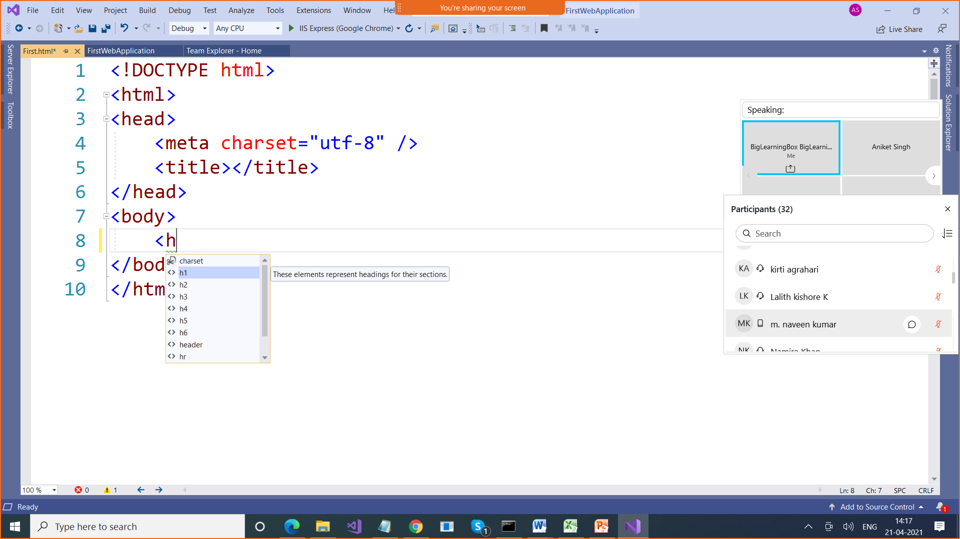

Intellisense > It gives you suggestions

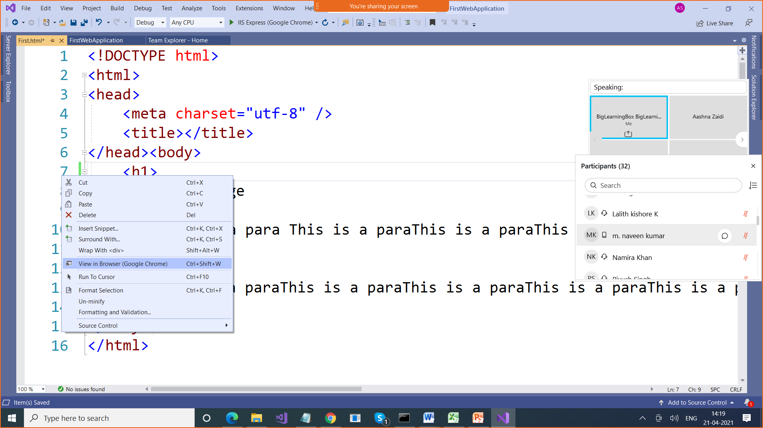

Semantic elements are the elements that tells us about what they are meant for by their names only > Meaningful for developers & for browser also

Helpful for SEO

Header , footer , table , small , article, section

Non Semantic elements > div , span , b , I , u , p

CSS : Cascading Style Sheet

Used to Decorate the web psges we use stylesheets

Different ways to style your elements

1. Inline style : while writing an element we use style

<div style="background-color:red; display:inline">100 </div>

1. Internal stylesheet : we create a stylesheet internally within the html page

Add style element in head element

<head>

<style>

div{

background-color:yellow;

display:inline;

}

</style>

There are different ways to refer to a style (selector)

1. By name p , body , h1 , div
2. By id which will be unique
3. By class for referring to multiple elements of different types

<!DOCTYPE html>

<html>

<head>

<style>

p{

width: 500px;

border-style: double;

border-color:yellow;

}

#id1 {

width: 500px;

border-style: double;

border-color: blue;

}

.p2 {

width: 500px;

border-style: dotted;

border-color: red;

}

</style>

<title> My web page </title>

</head>

<body style="background-color:green">

<h1 style="font-family:'Adobe Arabic';color:blue"> India </h1>

<h1 style="font-family:'Adobe Arabic';color:blue"> UK </h1>

<p style="width:100px">

This is some content 1

</p>

<p>

This is content 3

</p>

<p id="id1">

This is content 4

</p>

<p class="p2">

This is content 5

</p>

<p class="p2">

This is content 6

</p>

<div class="p2">

This is divsion

</div>

<div style="background-color:red; display:inline">100 </div>

<div style="background-color:red; display:inline-block; width:500px; height:200px">100 </div>

<div>2</div> <div>3</div> <div>4</div>

<p style="width:100px">

This is some content 2

</p>

<span style="background-color:red"> 1 </span> <span> 1 </span> <span> 1 </span> <span> 1 </span>

<form>

<fieldset>

<legend> Enter your Personal Details </legend>

<div>

Enter Name <input type="text" id="name" />

</div>

<div>

Enter Address <input type="text" id="name" />

</div>

<div>

Enter EMail <input type="email" id="email" />

</div>

<div>

Date of Joing <input type="date" id="doj" />

</div>

</fieldset>

<fieldset>

<legend> Enter Your Marks Details </legend>

<div>

Enter Marks of Englisf <input type="number" id="marks" min="0" max="100" />

</div>

<div>

Enter Marks of Englisf <input type="number" id="marks" min="0" max="100" />

</div>

<div>

Enter Marks of Englisf <input type="number" id="marks" min="0" max="100" />

</div>

<div>

Enter Marks of Englisf <input type="number" id="marks" min="0" max="100" />

</div>

</fieldset>

<input type="button" value="Submit" />

<input type="submit">

</form>

</body>

</html>

External stylesheet : separate css file containing style

p {

width: 500px;

border-style: double;

border-color: yellow;

}

#id1 {

width: 500px;

border-style: double;

border-color: blue;

}

.p2 {

width: 500px;

border-style: dotted;

border-color: red;

}

body{

background-image: url('Images/Penguins.jpg');

background-size: 100%;

background-repeat: no-repeat;

background-attachment: fixed;

}

To connect to or refer to that css file

<link href="customstylesheet.css" rel="stylesheet" />